Задача "Возможность расширения памяти по Oracle CLuster" (https://jira.tcsbank.ru/browse/IN-1177) [Светличный Алексей] [назначил Александров Алексей].
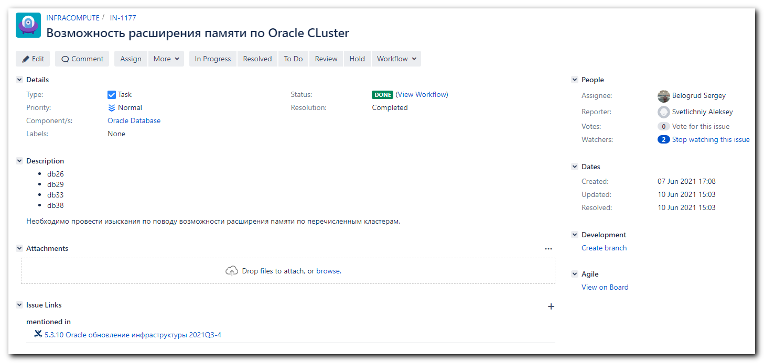
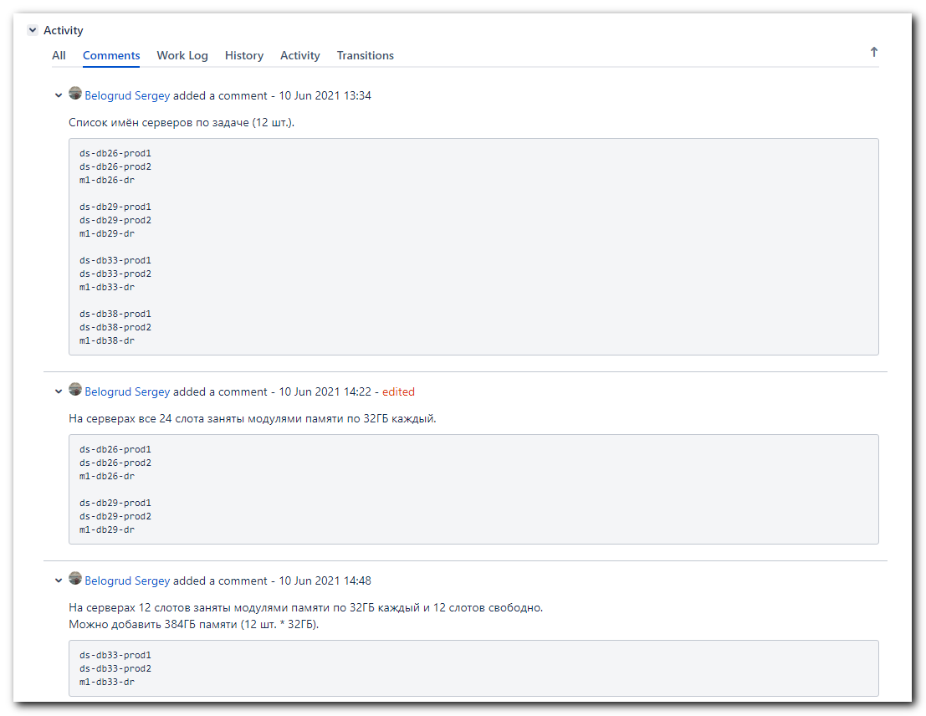
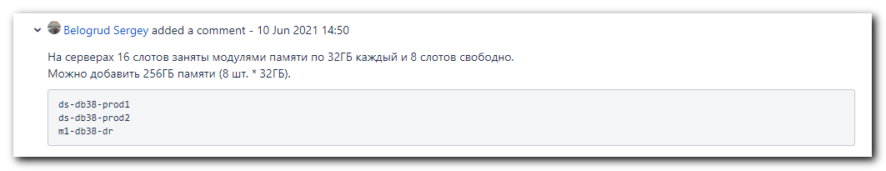

#
# I used my notes from this file.
20140508 iLO command line - investigation of usage .docx

#
# I found names of servers from nagios.
#
[root@vd-nag4-tst-1 objects]# pynag list host_name filename where object_type=host and host_name__contains="db26" --quiet #pynag_host
ds-db26-prod1 /usr/local/nagios/etc/objects/servers/db-servers/ds-db26-prod1.cfg
ds-db26-prod2 /usr/local/nagios/etc/objects/servers/db-servers/ds-db26-prod2.cfg
m1-db26-dr /usr/local/nagios/etc/objects/servers/db-servers/m1-db26-dr.cfg
[root@vd-nag4-tst-1 objects]# pynag list host_name filename where object_type=host and host_name__contains="db29" --quiet #pynag_host
ds-db29-prod1 /usr/local/nagios/etc/objects/servers/db-servers/ds-db29-prod1.cfg
ds-db29-prod2 /usr/local/nagios/etc/objects/servers/db-servers/ds-db29-prod2.cfg
m1-db29-dr /usr/local/nagios/etc/objects/servers/db-servers/m1-db29-dr.cfg
[root@vd-nag4-tst-1 objects]# pynag list host_name filename where object_type=host and host_name__contains="db33" --quiet #pynag_host
ds-db33-prod1 /usr/local/nagios/etc/objects/servers/db-servers/ds-db33-prod1.cfg
ds-db33-prod2 /usr/local/nagios/etc/objects/servers/db-servers/ds-db33-prod2.cfg
m1-db33-dr /usr/local/nagios/etc/objects/servers/db-servers/m1-db33-dr.cfg
[root@vd-nag4-tst-1 objects]# pynag list host_name filename where object_type=host and host_name__contains="db38" --quiet #pynag_host
ds-db38-prod1 /usr/local/nagios/etc/objects/servers/db-servers/ds-db38-prod1.cfg
ds-db38-prod2 /usr/local/nagios/etc/objects/servers/db-servers/ds-db38-prod2.cfg
m1-db38-dr /usr/local/nagios/etc/objects/servers/db-servers/m1-db38-dr.cfg
[root@vd-nag4-tst-1 objects]#

ds-db26-prod1
ds-db26-prod2
m1-db26-dr

ds-db29-prod1
ds-db29-prod2
m1-db29-dr

ds-db33-prod1
ds-db33-prod2
m1-db33-dr

ds-db38-prod1
ds-db38-prod2
m1-db38-dr

#
# I found iLO ip address from NetBox via field for search. I used masks "-db29-" and so on.
#

#
# I received info about memory modules and save it into appropriate files.
#
[s.belogrud@nb2339]# ssh -oPubkeyAuthentication=no tcsbank\\s.belogrud@10.219.108.214 "show -a system1/memory*^Mexit^M" | tee -a $(pwd)/$(date +%Y%m%d-%H%M).m1-db26-dr.memory.log.txt

[s.belogrud@nb2339]# ssh -oPubkeyAuthentication=no tcsbank\\s.belogrud@10.219.111.31 "show -a system1/memory*^Mexit^M" | tee -a $(pwd)/$(date +%Y%m%d-%H%M).ds-db26-prod1.memory.log.txt

[s.belogrud@nb2339]# ssh -oPubkeyAuthentication=no tcsbank\\s.belogrud@10.219.111.34 "show -a system1/memory*^Mexit^M" | tee -a $(pwd)/$(date +%Y%m%d-%H%M).ds-db26-prod2.memory.log.txt

[s.belogrud@nb2339]# ssh -oPubkeyAuthentication=no tcsbank\\s.belogrud@10.219.108.213 "show -a system1/memory*^Mexit^M" | tee -a $(pwd)/$(date +%Y%m%d-%H%M).m1-db29-dr.memory.log.txt

[s.belogrud@nb2339]# ssh -oPubkeyAuthentication=no tcsbank\\s.belogrud@10.219.111.19 "show -a system1/memory*^Mexit^M" | tee -a $(pwd)/$(date +%Y%m%d-%H%M).ds-db29-prod1.memory.log.txt

[s.belogrud@nb2339]# ssh -oPubkeyAuthentication=no tcsbank\\s.belogrud@10.219.111.26 "show -a system1/memory*^Mexit^M" | tee -a $(pwd)/$(date +%Y%m%d-%H%M).ds-db29-prod2.memory.log.txt

[s.belogrud@nb2339]# ssh -oPubkeyAuthentication=no tcsbank\\s.belogrud@10.219.108.212 "show -a system1/memory*^Mexit^M" | tee -a $(pwd)/$(date +%Y%m%d-%H%M).m1-db33-dr.memory.log.txt

[s.belogrud@nb2339]# ssh -oPubkeyAuthentication=no tcsbank\\s.belogrud@10.219.111.21 "show -a system1/memory*^Mexit^M" | tee -a $(pwd)/$(date +%Y%m%d-%H%M).ds-db33-prod1.memory.log.txt

[s.belogrud@nb2339]# ssh -oPubkeyAuthentication=no tcsbank\\s.belogrud@10.219.111.28 "show -a system1/memory*^Mexit^M" | tee -a $(pwd)/$(date +%Y%m%d-%H%M).ds-db33-prod2.memory.log.txt

[s.belogrud@nb2339]# ssh -oPubkeyAuthentication=no tcsbank\\s.belogrud@10.219.108.216 "show -a system1/memory*^Mexit^M" | tee -a $(pwd)/$(date +%Y%m%d-%H%M).m1-db38-dr.memory.log.txt

[s.belogrud@nb2339]# ssh -oPubkeyAuthentication=no tcsbank\\s.belogrud@10.219.111.49 "show -a system1/memory*^Mexit^M" | tee -a $(pwd)/$(date +%Y%m%d-%H%M).ds-db38-prod1.memory.log.txt

[s.belogrud@nb2339]# ssh -oPubkeyAuthentication=no tcsbank\\s.belogrud@10.219.111.24 "show -a system1/memory*^Mexit^M" | tee -a $(pwd)/$(date +%Y%m%d-%H%M).ds-db38-prod2.memory.log.txt

#
# Here I test my search expression to find number of memory modules installed and slots without memory modules installed.
[s.belogrud@nb2339]# grep -ie "size=" /drives/c/data/share/2021*memory.log.txt | less
[s.belogrud@nb2339]# grep -ie "size=" /drives/c/data/share/202106*-db33-dr.memory.log.txt
size=32768 MB
size=Not Installed
size=32768 MB
size=Not Installed
size=32768 MB
size=Not Installed
size=Not Installed
size=32768 MB
size=Not Installed
size=32768 MB
size=Not Installed
size=32768 MB
size=32768 MB
size=Not Installed
size=32768 MB
size=Not Installed
size=32768 MB
size=Not Installed
size=Not Installed
size=32768 MB
size=Not Installed
size=32768 MB
size=Not Installed
size=32768 MB
[s.belogrud@nb2339]#

# Here I counted numbers free slots without memory modules.
[s.belogrud@nb2339]# grep -ie "size=Not" /drives/c/data/share/202106*-db33-dr.memory.log.txt | wc -l
12
[s.belogrud@nb2339]# grep -ie "size=Not" /drives/c/data/share/202106*-db33-prod1.memory.log.txt | wc -l
12
[s.belogrud@nb2339]# grep -ie "size=Not" /drives/c/data/share/202106*-db33-prod2.memory.log.txt | wc -l
12
[s.belogrud@nb2339]# expr 12 \* 32
384
[s.belogrud@nb2339]#
[s.belogrud@nb2339]# grep -ie "size=Not" /drives/c/data/share/202106*-db38-dr.memory.log.txt | wc -l
8
[s.belogrud@nb2339]# grep -ie "size=Not" /drives/c/data/share/202106*-db38-prod1.memory.log.txt | wc -l
8
[s.belogrud@nb2339]# grep -ie "size=Not" /drives/c/data/share/202106*-db38-prod2.memory.log.txt | wc -l
8
[s.belogrud@nb2339]# grep -ie "size=32" /drives/c/data/share/202106*-db38-dr.memory.log.txt | wc -l
16
[s.belogrud@nb2339]# expr 8 \* 32
256
[s.belogrud@nb2339]#

